FLOOD MONITORNING AND EARLY WARNING

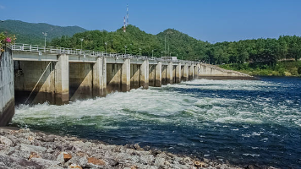

**By**

**S.shivani**

**S.Thara**

**D.Sree Sanjana**

**S.Saranya**

**ARCHITECTURE**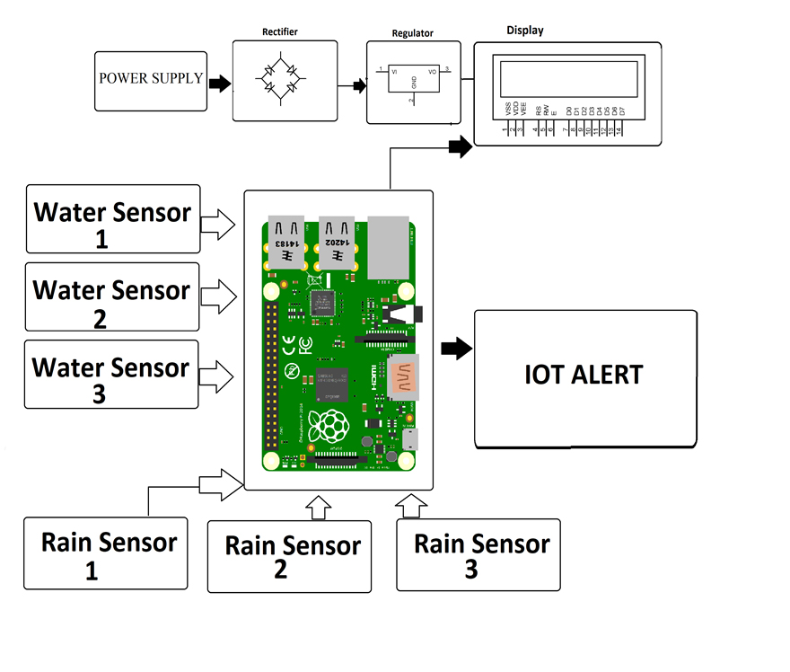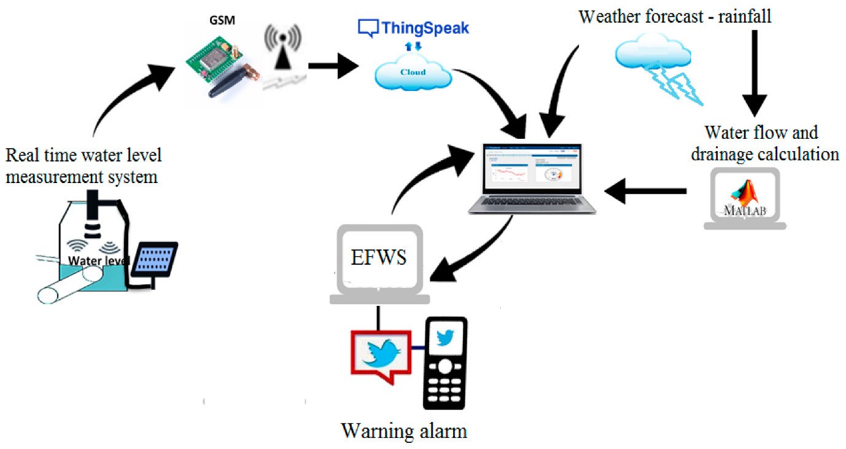

**DATA COLLECTION**

1.Historical Flood Data:

* + Collect historical flood data spanning several years or decades for the target region.
  + Include details such as the date and time of past flood events, the location affected, flood severity (e.g., flood levels or flood stages), and any relevant causes or triggers.

1. Real-Time Data Sources:
   * Identify and establish connections to real-time data sources. This may include data on river levels, rainfall, weather forecasts, and soil moisture levels.
   * Ensure the availability and reliability of these sources to provide timely information.
2. Data Quality:
   * Scrutinize historical data for completeness, accuracy, and consistency. Address any data quality issues through cleaning and preprocessing.
   * Implement quality control checks to filter out erroneous or unreliable real-time data.
3. Metadata and Documentation:

## Maintain detailed metadata and documentation for all collected data. This should include information on data sources, data collection methods, and any modifications made to the data.

1. Data Storage and Management:
   * Set up a secure and scalable data storage system to store historical and real-time data.
   * Consider using database systems or cloud storage solutions for efficient data management.
2. Legal and Ethical Considerations:
   * Ensure compliance with data privacy laws and regulations when collecting and storing data, especially if it includes personally identifiable information (PII).
   * Obtain necessary permissions and approvals for data sharing if applicable.
3. Data Synchronization:
   * Implement mechanisms to synchronize real-time data sources with your data storage system at regular intervals. This ensures that you have access to the most up-to-date information.
4. Backup and Redundancy:
   * Establish backup and redundancy measures to prevent data loss in case of system failures or disasters.
5. Data Access and Security:
   * Control access to the data to prevent unauthorized use or tampering. Implement appropriate security measures to protect sensitive data.
6. Data Retention Policy:
   * Define a data retention policy to manage the storage of historical data. Determine how long you need to retain past data for analysis and compliance purposes.
7. Data Formats:
   * Ensure that historical and real-time data are in compatible formats for analysis and integration with predictive models.
8. Data Sources Diversity:
   * Consider using data from multiple sources to enhance the accuracy and reliability of predictions. Diverse data sources can provide complementary information.
9. Data Volume and Scalability:
   * Plan for scalability as your data volume grows over time. Ensure that your data infrastructure can handle increased data loads.

**DATA PREPROCESSING**

1. **Data Cleaning**:
   * Identify and handle missing data: Determine how to handle missing values, whether by imputation, deletion, or interpolation, based on the nature of the data and the impact of missing values on analysis.
   * Address outliers: Identify and treat outliers that may skew your analysis or modeling results. You can use statistical methods like the IQR (Interquartile Range) or domain knowledge to identify outliers.
2. **Data Transformation**:
   * Normalization and scaling: Standardize numerical features to have a common scale (e.g., using z-scores) to prevent certain variables from dominating others in modeling.
   * One-hot encoding: Convert categorical variables into numerical format, typically using one-hot encoding, to make them usable in machine learning models.
   * Feature engineering: Create new features or transform existing ones based on domain knowledge or data exploration to capture meaningful patterns.
3. **Handling Imbalanced Data**:
   * In flood prediction, you may encounter imbalanced datasets where flood events are relatively rare. Employ techniques like oversampling the minority class or undersampling the majority class to balance the dataset.
4. **Temporal Data Handling**:
   * If your data has a temporal component, ensure that it's appropriately sorted or indexed by time to capture trends and seasonality.
   * Calculate rolling statistics (e.g., moving averages) to identify temporal patterns.
5. **Feature Selection**:
   * Select the most relevant features for modeling to reduce dimensionality and potentially improve model performance.
   * Use techniques like feature importance ranking or recursive feature elimination.
6. **Data Integration**:
   * Merge or join data from different sources if you're working with data from various sensors or locations. Ensure consistent data formats and units.
7. **Data Splitting**:
   * Divide the dataset into training, validation, and test sets. The training set is used to train the model, the validation set to tune hyperparameters, and the test set to evaluate the model's generalization performance.
8. **Data Scaling**:
   * If using algorithms sensitive to feature scale (e.g., gradient descent), apply scaling methods like Min-Max scaling or Standardization (z-score scaling) to ensure fair model training.
9. **Data Normalization**:
   * Normalize time series data if needed to account for seasonality or trends, which may improve the model's ability to learn patterns.
10. **Handling Time Lags**:
    * If relevant, introduce time lags to capture delayed effects of rainfall or other factors on flood occurrences.
11. **Validation Data Preparation**:
    * Ensure that the validation and test datasets are consistent with the training data in terms of preprocessing steps. Any transformations applied to the training data should also be applied to these datasets.
12. **Documentation**:
    * Maintain clear documentation of all preprocessing steps performed, as this is essential for reproducibility and troubleshooting.

**FEATURE ENGINEERING**

1. **Domain Knowledge**:
   * Begin by leveraging domain knowledge and expertise in flood prediction to identify potentially relevant features. Collaborate with hydrologists, meteorologists, and other experts in the field.
2. **Feature Extraction**:
   * Extract relevant information from the data that can be used as features. For example, calculate statistics such as mean, median, minimum, maximum, and standard deviation from historical flood data.
3. **Temporal Features**:
   * Incorporate time-related features, such as the day of the week, month, or year, to capture seasonality and temporal patterns in flood events.
   * Consider creating lag features to account for delayed effects of rainfall or other factors on flood occurrences.
4. **Spatial Features**:
   * If your data covers a geographic area, create spatial features like distance to rivers, elevation, land use, or proximity to water bodies, which can provide valuable information.
5. **Weather and Climate Data**:
   * Integrate weather and climate data as features, such as rainfall intensity, temperature, humidity, and wind speed, to account for meteorological influences on flooding.
6. **Hydrological Features**:
   * Develop features related to hydrological factors, such as river discharge, groundwater levels, and soil moisture, which play a significant role in flood prediction.
7. **Historical Information**:
   * Include historical flood data as features, such as the number of past flood events, the duration of previous floods, or the time since the last flood event.
8. **Aggregate and Rolling Statistics**:
   * Compute rolling statistics, moving averages, or cumulative sums for various variables to capture trends and patterns in the data.
9. **Interaction Features**:
   * Create interaction features that represent the combination of two or more variables. For instance, the product of rainfall intensity and river level might be more informative than the individual variables.
10. **Dimensionality Reduction**:
    * If dealing with high-dimensional data, consider dimensionality reduction techniques like Principal Component Analysis (PCA) or feature selection algorithms to select the most relevant features.
11. **Feature Scaling**:
    * Ensure that all engineered features are on a consistent scale to prevent certain features from dominating the model due to their larger magnitude.
12. **Feature Importance Analysis**:
    * Use feature importance techniques (e.g., feature importance scores from tree-based models) to identify which features are most influential for the predictive model.
13. **Regularization**:
    * When training models, consider using regularization techniques (e.g., L1 or L2 regularization) to automatically select relevant features and reduce overfitting.
14. **Cross-Validation**:
    * Perform feature engineering within a cross-validation framework to avoid data leakage and assess how well your features generalize across different data subsets.
15. **Iterative Process**:
    * Feature engineering is often an iterative process. Continuously evaluate and refine your engineered features based on model performance and domain insights.

**PREDICTIVE MODELING**

1. **Model Selection**:
   * Choose an appropriate machine learning or statistical model for your specific predictive task. Common models for flood prediction include Random Forest, Gradient Boosting, Support Vector Machines (SVM), and Neural Networks.
2. **Hyperparameter Tuning**:
   * Optimize model hyperparameters through techniques like grid search, random search, or Bayesian optimization to find the best configuration for your data.
3. **Training and Validation**:
   * Split your dataset into training, validation, and test sets. Use the training set to train the model, the validation set to tune hyperparameters, and the test set to evaluate model performance.
4. **Time-Series Considerations**:
   * If dealing with time-series data, ensure that your model accounts for temporal dependencies. Consider using recurrent neural networks (RNNs) or convolutional neural networks (CNNs) for sequence-based data.
5. **Cross-Validation**:
   * Implement cross-validation techniques, such as k-fold cross-validation, to assess model generalization performance. This helps detect overfitting and provides a more reliable estimate of model accuracy.
6. **Feature Importance Analysis**:
   * Analyze feature importance scores to understand which features are most influential in making predictions. This insight can guide feature selection and model interpretation.
7. **Ensemble Methods**:
   * Experiment with ensemble methods like bagging (e.g., Random Forest) and boosting (e.g., Gradient Boosting) to improve model performance by combining multiple base models.
8. **Regularization**:
   * Apply regularization techniques like L1 (Lasso) or L2 (Ridge) regularization to prevent overfitting and enhance model robustness.
9. **Evaluation Metrics**:
   * Select appropriate evaluation metrics for your specific problem, such as accuracy, precision, recall, F1-score, ROC-AUC, or mean absolute error (MAE). The choice of metric depends on the nature of the problem (classification or regression).
10. **Threshold Tuning**:
    * Adjust decision thresholds to balance precision and recall based on the specific requirements of your early warning system. This step is particularly important for classification models.
11. **Model Interpretability**:
    * Consider the interpretability of your model. For some applications, it's essential to have models that can provide insights into why a particular prediction was made.
12. **Deployment and Integration**:
    * Integrate the trained predictive model into your early warning system, ensuring that it can take real-time data inputs and produce timely predictions.
13. **Monitoring and Maintenance**:
    * Regularly monitor the performance of your predictive model in production and update it as needed. Models may drift over time due to changes in data distribution.
14. **Feedback Loop**:
    * Establish a feedback loop to collect data on the effectiveness of the early warning system and model predictions during real flood events. Use this feedback to improve the system continuously.
15. **Documentation**:
    * Document the model architecture, hyperparameters, and any specific considerations related to the predictive modeling process. This documentation aids in model maintenance and replication.
16. **Communication and Reporting**:
    * Communicate model results and predictions effectively to relevant stakeholders, emergency response teams, and the public, as appropriate.
17. **Validation and Testing**:
    * Validate the model's predictions against historical flood events and conduct thorough testing before deploying it in a critical operational environment.

**MODEL VALIDATION**

1. **Training and Validation Split:**
   * Split your dataset into training and validation sets (e.g., 80% for training and 20% for validation) or use techniques like k-fold cross-validation.
2. **Training Phase:**
   * Train your predictive model using the training dataset. The model learns the underlying patterns and relationships in the data during this phase.
3. **Validation Phase:**
   * Evaluate the model's performance on the validation dataset, which it has never seen before.
   * Calculate various evaluation metrics (e.g., accuracy, precision, recall, F1-score, ROC-AUC, or mean squared error) to assess how well the model is performing.
4. **Model Assessment:**
   * Analyze the validation metrics to gauge the model's performance. The choice of metrics depends on whether you are solving a classification or regression problem.
5. **Hyperparameter Tuning:**
   * If the model's performance is suboptimal, consider tuning hyperparameters (e.g., learning rate, number of trees in a Random Forest, etc.) to improve results.
6. **Repeat if Necessary:**
   * If the model's performance is unsatisfactory, you may need to iterate on the model selection and tuning process.
7. **Final Model Selection:**
   * Once you are satisfied with the model's performance on the validation dataset, finalize the model for deployment

**INTEGRATION WITH EARLY WARNING SYSTEM**

1. **Model Output Format:**
   * Ensure that the predictive model outputs predictions in a format compatible with the early warning system. This may involve defining standardized data formats and protocols.
2. **Real-Time Data Input:**
   * Establish mechanisms to feed real-time data, such as river levels, rainfall data, and weather forecasts, into the predictive model. This data serves as input for generating predictions.
3. **Thresholds and Triggers:**
   * Set up thresholds and triggers based on the model's predictions. Determine at what levels of risk or probability a flood warning should be issued.
4. **Alert Generation:**
   * Implement the logic for generating flood alerts or warnings based on the model's predictions and the defined thresholds.
5. **Communication Channels:**
   * Integrate various communication channels into the early warning system to disseminate alerts. This can include SMS messages, email notifications, mobile apps, sirens, and public broadcasts.
6. **Visualization Tools:**
   * Develop visualization tools that display the model's predictions, historical data, and real-time data to assist decision-makers and the public in understanding the flood risk.
7. **Geospatial Integration:**
   * If relevant, integrate geographical information systems (GIS) to map flood-prone areas and display alerts on maps for better visualization.
8. **User Access Control:**
   * Implement user access control and authentication mechanisms to ensure that only authorized personnel can access and modify the early warning system.
9. **Testing and Validation:**
   * Thoroughly test the integrated system to ensure that alerts are generated and disseminated correctly during simulated flood events.

**CONTINUOUS MONITORNING AND UPDATES**

1. **Real-Time Data Monitoring**:
   * Continuously monitor the quality and availability of real-time data sources, including river levels, rainfall data, weather forecasts, and other relevant information.
   * Implement automated alerts for data anomalies or issues that could affect the predictive model's performance.
2. **Model Performance Monitoring**:
   * Set up mechanisms to monitor the performance of the predictive model in real-time. This includes tracking key performance metrics, such as accuracy, precision, recall, and F1-score.
3. **Data Drift Detection**:
   * Implement data drift detection techniques to identify changes in the data distribution over time. Data drift can impact the model's accuracy, so it's essential to detect and adapt to these changes.
4. **Model Retraining**:
   * Establish a schedule or trigger conditions for retraining the predictive model. Regularly retraining the model with fresh data helps it stay up-to-date and adapt to changing conditions.
   * Decide whether to use online learning techniques that allow the model to update incrementally with each new data point or batch retraining on a periodic basis.
5. **Version Control**:
   * Maintain version control for both the model and the data. This enables you to track changes, revert to previous versions if necessary, and ensure reproducibility.
6. **Automated Alerts**:
   * Implement automated alerts to notify system administrators or relevant personnel when the model's performance drops below acceptable thresholds or when data anomalies are detected.
7. **Feedback Loop from Events**:
   * After a flood event occurs, collect data on the accuracy of the early warning system's predictions and the actual outcomes. Use this feedback to fine-tune the model and improve future predictions.
8. **External Factors and Calibrations**:
   * Consider external factors such as infrastructure changes, land use, or climate patterns that may impact flood risk. Update the model or its parameters to account for such changes.
9. **Emergency Response Drills**:
   * Conduct regular emergency response drills and simulations to test the effectiveness of the early warning system and ensure that response teams are well-prepared.
10. **Stakeholder Engagement**:
    * Engage with relevant stakeholders, including meteorologists, hydrologists, local authorities, and the public, to gather feedback and insights on system performance.
11. **Legal and Ethical Compliance**:
    * Ensure that the continuous monitoring and updating processes comply with data privacy and security regulations, especially when dealing with sensitive information.
12. **Documentation and Reporting**:
    * Maintain detailed documentation of all monitoring and update activities, including any changes made to the predictive model or data preprocessing steps.
    * Provide regular reports on system performance and updates to stakeholders.
13. **Budget and Resource Allocation**:
    * Allocate resources and budget for the ongoing maintenance and improvement of the early warning system.

**COMMUNICATION AND EDUCATION**

1. **Public Awareness**:
   * Develop public awareness campaigns to educate residents and communities about the flood early warning system.
   * Use various communication channels, including social media, websites, and local news outlets, to reach a wide audience.
2. **Clear Messaging**:
   * Craft clear and concise messages that explain the purpose of the early warning system, how it works, and what actions individuals should take in response to warnings.
   * Use plain language and avoid technical jargon to ensure broad comprehension.
3. **Multilingual Materials**:
   * If the community includes speakers of multiple languages, provide materials and communications in different languages to ensure inclusivity.
4. **Education Programs**:
   * Develop educational programs in schools and community centers to teach students and residents about flood risks, preparedness, and the early warning system.
5. **Public Workshops and Seminars**:
   * Conduct public workshops, seminars, or town hall meetings to engage with the community directly, answer questions, and gather feedback.
6. **Engagement with Stakeholders**:
   * Collaborate with local authorities, emergency responders, and relevant organizations to ensure that they understand the system's capabilities and can coordinate effectively during flood events.
7. **User-Friendly Interfaces**:
   * Design user-friendly interfaces for mobile apps, websites, or other tools that provide access to the early warning system's information.
   * Ensure that users can easily access flood risk information, check alerts, and understand the presented data.
8. **Regular Updates**:
   * Keep the public informed with regular updates, even during periods of low flood risk. This helps maintain awareness and readiness.
9. **Customized Alerts**:
   * Allow users to customize alert preferences based on their location and individual needs, such as receiving notifications only for specific flood risk levels.
10. **Training for First Responders**:
    * Provide specialized training for first responders, emergency personnel, and local authorities on how to interpret and respond to early warnings effectively.
11. **Realistic Drills and Exercises**:
    * Organize realistic drills and exercises to simulate flood events and test the early warning system's functionality and community response.
12. **Feedback Mechanisms**:
    * Establish mechanisms for the public to provide feedback on the early warning system, report issues, and suggest improvements.
13. **Crisis Communication Plan**:
    * Develop a crisis communication plan that outlines how to communicate during high-stress situations, ensuring that information is conveyed calmly and efficiently.
14. **Transparency and Accountability**:
    * Maintain transparency in the system's operations, data sources, and performance metrics to build trust with the community and stakeholders.
15. **Continuous Evaluation**:
    * Continuously evaluate the effectiveness of your communication and education efforts and adjust strategies based on feedback and outcomes.
16. **Cultural Sensitivity**:
    * Be culturally sensitive in your messaging and education programs to ensure that they resonate with the local community.

**EMERGENCY RESPONSE PLANS**

1. **Risk Assessment:**
   * Conduct a comprehensive risk assessment to understand the potential impact of floods in different areas and identify vulnerable communities.
2. **Collaboration:**
   * Collaborate with local authorities, emergency services, and relevant organizations to develop a coordinated response plan.
3. **Roles and Responsibilities:**
   * Clearly define the roles and responsibilities of each entity involved in the response, including who is responsible for issuing and disseminating flood alerts.
4. **Evacuation Plans:**
   * Develop evacuation plans for flood-prone areas, including evacuation routes, assembly points, and transportation arrangements.
5. **Shelter and Relief Centers:**
   * Identify and establish shelters and relief centers where affected individuals and families can seek refuge, receive assistance, and access essential supplies.
6. **Communication Protocols:**
   * Establish communication protocols to ensure that information flows smoothly between different response teams and agencies. Use AI-powered communication tools for real-time updates.
7. **Resource Allocation:**
   * Allocate necessary resources such as personnel, equipment, and medical supplies to respond effectively to flood emergencies.

**Training and Drills:**

* + Conduct regular training sessions and drills to familiarize response teams with the emergency plan and test their readiness.

1. **Flood Early Warning System Integration:**
   * Integrate the flood early warning system with the emergency response plan to ensure that alerts trigger immediate action.
2. **Community Engagement:**
   * Educate the community about the emergency response plan, evacuation procedures, and the importance of following official guidance.
3. **Accessibility:**
   * Ensure that the emergency response plan is accessible to individuals with disabilities or those who require special assistance.
4. **Crisis Communication:**
   * Develop a crisis communication plan to inform the public and stakeholders about the situation, including evacuation orders and shelter locations.